

NATIONAL UNIVERSITY OF COMPUTER AND EMERGING SCIENCES

(KARACHI CAMPUS)

**(PARALLEL AND DISTRIBUTED COMPUTING PROJECT)**

PROJECT TITLE

**"LCS and LU Decomposition in Open mp and MPI”**

COURSE INSTRUCTOR

**Ms. Nausheen Shoaib**

**TEAM MEMBERS:**

Abdul Wasay (21K-4589)

Ashish Kumar(21K-3451)

Naqeeb Nadir(21K-3317)

**INTRODUCTION:**

**LU (Lower-Upper) decomposition and LCS (Longest Common Subsequence) are fundamental numerical techniques employed in parallel computing environments, such as OpenMP and MPI. LU decomposition is a method used for solving systems of linear equations by decomposing a matrix into lower and upper triangular matrices. This technique is valuable for parallelizing matrix operations, enhancing computational efficiency in shared-memory architectures like OpenMP. On the other hand.**

**LCS decomposition is a dynamic programming approach widely used in parallel computing, particularly with MPI, to efficiently find the longest common subsequence in two sequences. These parallel decomposition methods play crucial roles in optimizing performance and accelerating computations in parallel and distributed computing environments.**

**Methodology:**

* Longest Common Subsequence Psudocode:

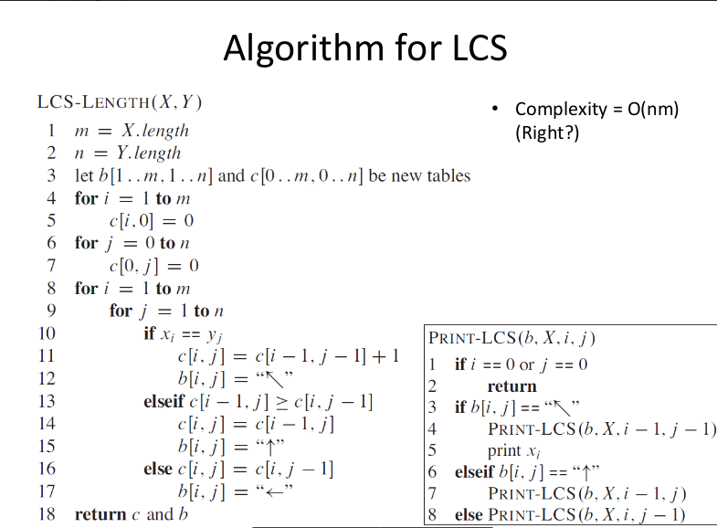

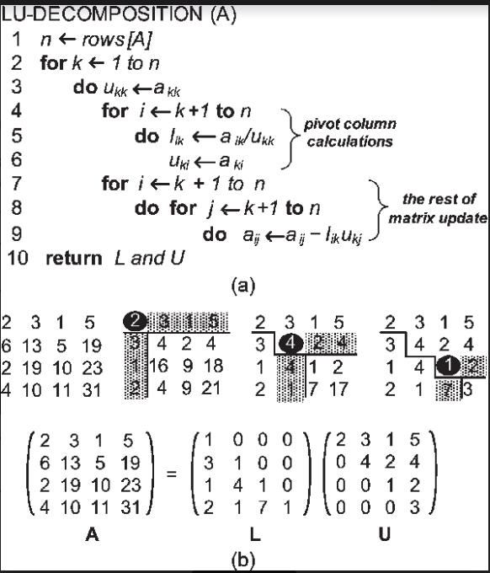

* <https://www.researchgate.net/figure/a-LU-decomposition-pseudocode-b-Example-on-LU-decomposition_fig4_220624910>

(For LU Decomposition)

(For LCS) Introduction to Algorithm 3rd Edition

Thomas H Cormen

Charles E Leiserson

* **Refrences:**
* [**https://www.researchgate.net/publication/252320985_Parallel_Computing_the_Longest_Common_Subsequence_LCS_on_GPUs_Efficiency_and_Language_Suitabilit**](https://www.researchgate.net/publication/252320985_Parallel_Computing_the_Longest_Common_Subsequence_LCS_on_GPUs_Efficiency_and_Language_Suitabilit)
* [**https://dl.ebooksworld.ir/books/Introduction.to.Algorithms.4th.Leiserson.Stein.Rivest.Cormen.MIT.Press.9780262046305.EBooksWorld.ir.pdf**](https://dl.ebooksworld.ir/books/Introduction.to.Algorithms.4th.Leiserson.Stein.Rivest.Cormen.MIT.Press.9780262046305.EBooksWorld.ir.pdf)

**PERFORMANCE COMPARISON (OPENMP vs MPI):**

* Longest Common Subsequence Graph:

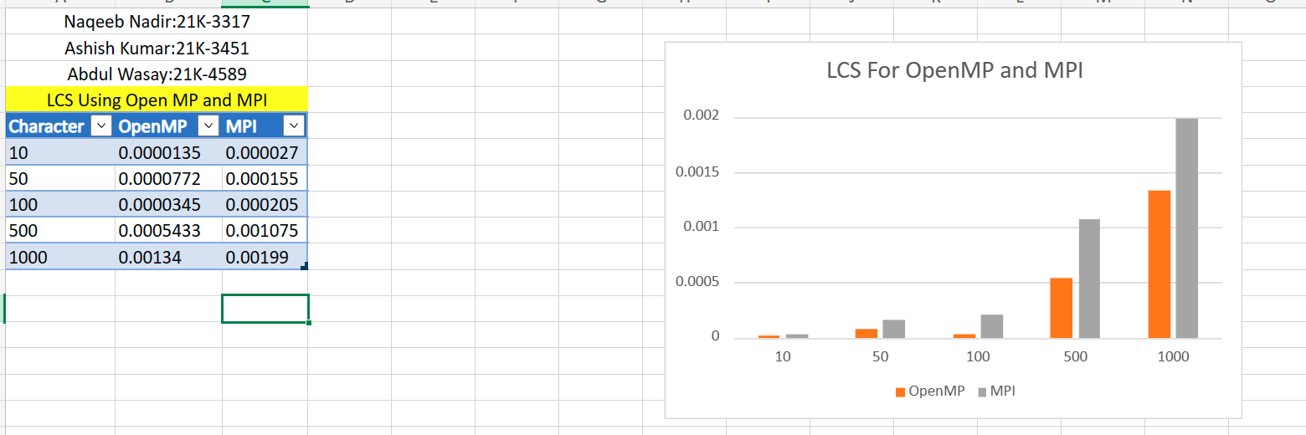

Longest Common Subsequence Communication and Computation Graph:

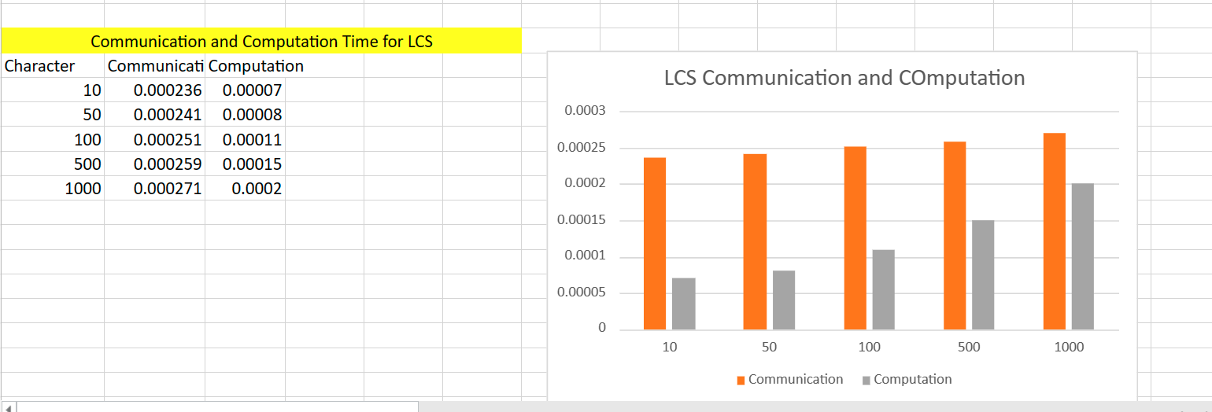

LU Decomposition Graph:

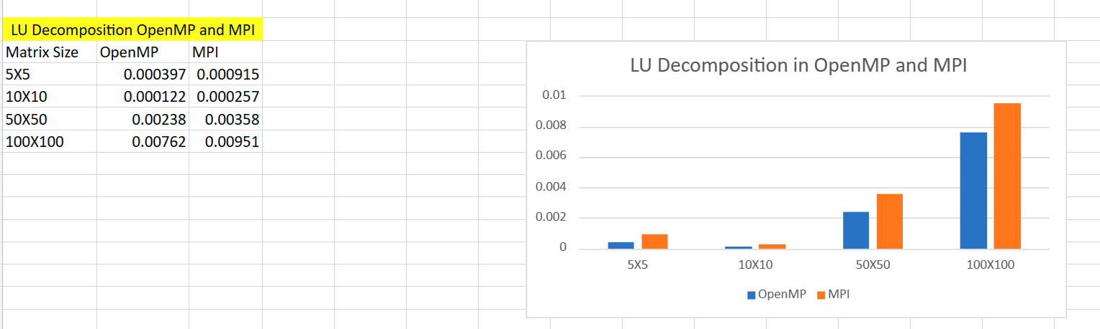

LU Decomposition Communication and Computation Graph:

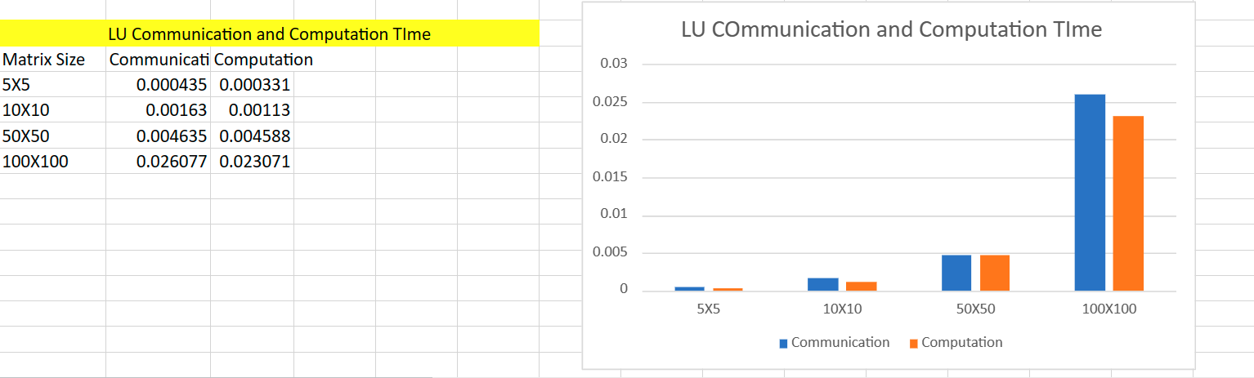

**CONCLUSION:**

**In conclusion, the LU (Lower-Upper) and LCS (Longest Common Subsequence) decomposition project implemented using MPI (Message Passing Interface) and OpenMP has been a significant endeavor that underscores the power of parallel and distributed computing in solving complex numerical and string-based problems.**

**The utilization of MPI allowed for the efficient distribution of tasks across multiple processors, fostering parallelism and enabling the decomposition algorithms to handle larger datasets and matrices. The communication and coordination among different processes facilitated the seamless execution of the LU decomposition, breaking down matrices into lower and upper triangular components, and the LCS decomposition, identifying the longest common subsequence in strings.**